
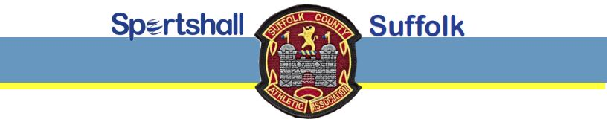

COMPETITIONS FOR THE WINTER SEASON 2026/27

SUFFOLK COMPETITIONS:

IPSWICH SPORTSHALL COMPETITION

Date: Saturday 24th October 2026 Time: 13:00 to 17.00
Venue: Northgate Sports Centre, Sidegate Lane, Ipswich IP4 3DL
Entry fee: £7 per athlete. Closing date for entries: Tuesday 20th October 2026

NEWMARKET SPORTSHALL COMPETITION

Date: Saturday 7th November 2026 Time: 13.00 to 17.00
Venue: Newmarket Leisure Centre, Exning Road, Newmarket, CB8 0EA
Entry fee: £7 per athlete. Closing date for entries: Tuesday 3rd November 2026

2026/27 SUFFOLK CHAMPIONSHIPS IN LOWESTOFT

Date: Saturday 14th November 2026 Time: 13:00 to 17.00
Venue: Waterlane Leisure Centre, Water Lane, Lowestoft, NR32 2NH
Entry fee: £7 per athlete. Closing date for entries: Tuesday 10th November 2026

EAST REGION SPORTSHALL FINALS:

Date: Saturday 27th February 2027 Time: TBA
Venue: University of East Anglia, Norwich
Based on results from the Suffolk competitions, athletes will be invited to represent Suffolk


AGE GROUPS

Girls and Boys ages are as at 31st August/1st September 2026:

U10 (school years 3/4), U12 (school years 5/6),
U14 (school years 7/8), U16 (school years 9/10)

FOR ENTRY FORMS / PAYMENT DETAILS / MORE INFORMATION

Visit website: https://suffolkathletics.org.uk/sportshall/

General queries - email: sportshall@suffolkathletics.org.uk

