****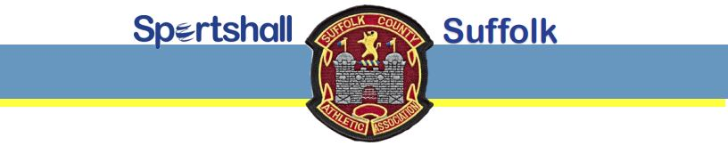

**COMPETITIONS FOR THE WINTER SEASON 2025/26**

**SUFFOLK COMPETITIONS:**

*IPSWICH SPORTSHALL COMPETITION*

Date: **Saturday 4th October 2025** Time: 13:00 to 17.00

Venue: **Northgate Sports Centre** - Sidegate Lane, Ipswich IP4 3DL

Entry fee: £5 per athlete. Closing date for entries: Tuesday 30th September 2025

*LOWESTOFT SPORTSHALL COMPETITION*

Date: **Saturday 8th November 2025** Time: 13.00 to 17.00

Venue: **Waterlane Leisure Centre** - Water Lane, Lowestoft, NR32 2NH

Entry fee: £5 per athlete. Closing date for entries: Tuesday 4th November 2025

*2025/26 SUFFOLK CHAMPIONSHIPS IN IPSWICH*

Date: **Saturday 22nd November 2025** Time: 13:00 to 17.00

Venue: **Northgate Sports Centre** - Sidegate Lane, Ipswich IP4 3DL

Entry fee: £5 per athlete. Closing date for entries: Tuesday 18th November 2025

**EAST REGION SPORTSHALL FINALS:**

Date: **Sunday 1st February 2026** Time: TBA

Venue: **University of East Anglia**, Norwich

Based on results from the Suffolk competitions, athletes will be invited to represent Suffolk



**AGE GROUPS**

Girls and Boys ages are as at 31st August/1st September 2025:

U11 (school years 4/5/6), U13 (school years 7/8), U15 (school years 9/10)

**FOR ENTRY FORMS / PAYMENT DETAILS / MORE INFORMATION**

Visit website: **https://suffolkathletics.org.uk/sportshall/**

General queries - email: **sportshall@suffolkathletics.org.uk**